**lab practice 2**

In this programming lab, you will implement a reliable data transmission simulation based on the Stop-andWait protocol, including both client-side and server-side code. The Stop-and-Wait protocol is a simple. Automatic Repeat reQuest (ARQ) protocol that ensures reliable delivery of data during network transmission. You will complete the TODO sections in the provided code to achieve stable data transmission between the client and the server.

We compute the time ourselves to replace the timeout method given in the socket. If there’s a timeout, we break the receiving logic to resend the package.

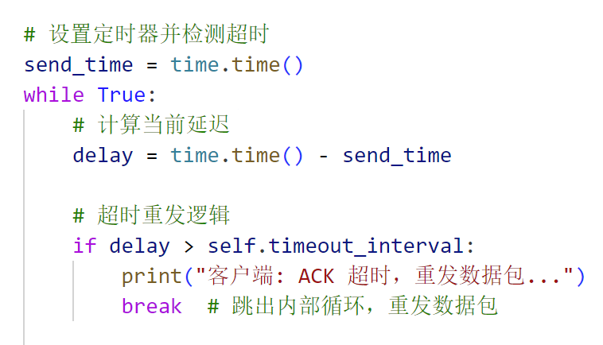

The result we get is: (time delay of the protocol, which shows the performance)

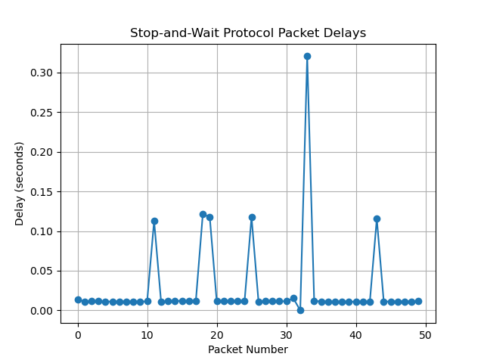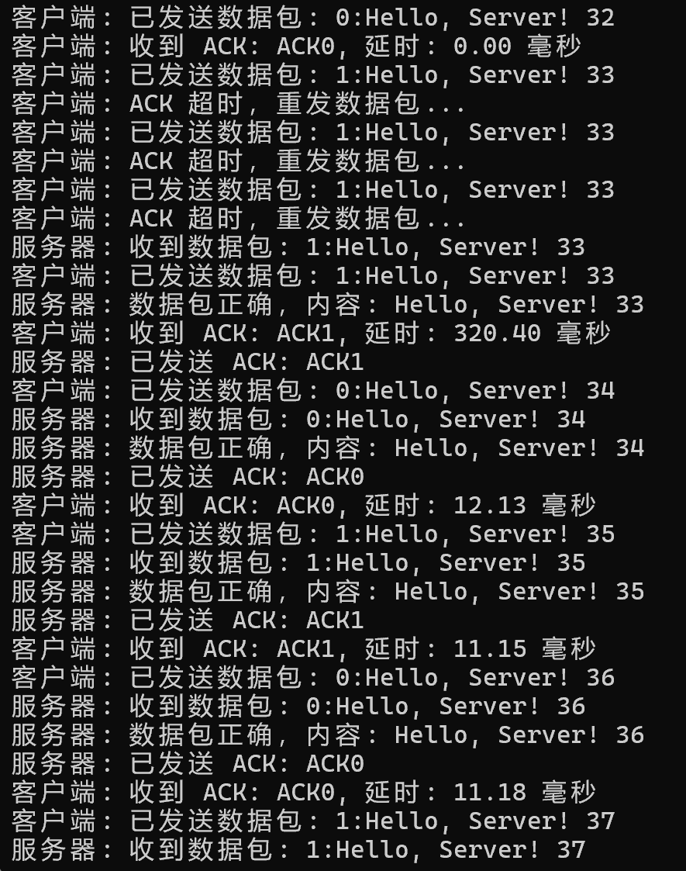

Since our unreliable transport protocol has code written into it that makes it possible to lose packets, it's not unusual for delays to occur, with longer delays caused by not receiving an ACK and then retransmitting it.

Set loss_prob=0.1, and there’s 6 timeout in 50 attempts, 12% is in accordance with the packet loss rate.